
TERTIARY INFOTECH ACADEMY • NON-WSQ COURSE
LEARNER GUIDE
Microsoft Copilot for HR
Course Code: C820
2 days / 15 hours
UEN 201200696W
Version 1.0 • 4 October 2026

Document Version Control
Version | Date | Summary
1.0 | 4 October 2026 | Non-WSQ edition of Microsoft Copilot for HR (C820): 194 slides, LG, LP and 12 labs; 9:30am - 5:30pm schedule, 7.5 instructional hours per day.
Version numbers apply to this generated courseware release.

Contents

How to use this guide
The slide deck explains concepts visually. This Learner Guide contains the detailed activity procedures, prompts, evidence requirements and questions. All cases and records are synthetic for learning; do not substitute live employee data.

Course information
Field | Detail
Course | Microsoft Copilot for HR
Course code | C820
Duration | 2 days / 15 hours (9:30am – 5:30pm daily)
Trainer | Dr. Alfred Ang

Learning outcomes
- LO1. Compare how generative and agentic AI reshape HR operating models versus conventional HR delivery.
- LO2. Analyse where Microsoft 365 Copilot and AI agents can improve end-to-end HR processes and employee experience.
- LO3. Conduct feasibility analysis and design a governed implementation for an HR generative-AI or agentic-AI use case.
- LO4. Apply legal, ethical, privacy, security, fairness and human-oversight controls to AI-enabled HR work.

The course message
Use AI to | Operational effect | Value released
Reduce administrative work | Automate repetitive search, drafting, rekeying, routing, reminders and status updates | More time for complex employee needs
Improve productivity and efficiency | Shorten cycle time while improving consistency, traceability and service access | More reliable HR delivery at scale
Focus HR on strategic value | Return capacity to workforce planning, coaching, culture, organisation design and employee care | A stronger connection between the people agenda and business outcomes
The objective is not to remove human accountability. Copilot accelerates knowledge work; bounded agents coordinate approved work; authorised HR professionals remain responsible for consequential decisions and human conversations.

Platform model
Need | Preferred Microsoft capability | Human role
Draft, summarise, compare or analyse | Microsoft 365 Copilot in Word, Excel, Outlook, Teams | Provide context, verify evidence and approve output
Focused team Q&A over approved knowledge | Agent Builder in Microsoft 365 Copilot | Curate knowledge, test and manage sharing
Multi-step workflow across systems | Microsoft Copilot Studio with tools/agent flows | Approve consequential actions and operate controls

Reference case vignettes
The user-supplied ebook presents four unnamed implementation vignettes. They are included as secondary-source discussion cases; the reported organisations are not independently identified in the reference.

Technology — recruitment
AI-assisted screening and candidate chat reportedly shortened the hiring cycle by 30% while supporting diversity-oriented process improvements.

Retail — engagement and retention
Feedback and sentiment analysis informed targeted interventions associated with a reported 20% reduction in turnover.

Financial services — talent development
Predictive talent evidence supported succession planning, leadership-pipeline decisions and personalised development.

Healthcare — performance and coaching
More timely performance evidence enabled earlier coaching and more consistent reviews.
Discussion: What administrative work was reduced? What evidence suggests productivity or service improvement? Which strategic HR activity became more possible? What safeguards and verification would be required before applying the pattern?

Contents and slide alignment
Unit | Coverage | Slides
1 | From Generative AI to Agentic HR | 11–57
2 | Microsoft 365 Copilot Across the HR Lifecycle | 58–100
3 | Build Governed HR Agents | 101–142
4 | Responsible Adoption and HR Transformation | 143–187

Learning Unit 1: From Generative AI to Agentic HR
Choose the lightest capability that safely solves the work

Concept notes

Today's HR operating pain
Fragmented channels and repeated hand-offs trap HR capacity in administration.
- Requests arrive through email, forms and chat with no shared case view
- HR rekeys the same data across trackers, documents and systems
- Employees and managers wait for inconsistent answers and approvals
- Evidence, ownership and exceptions are difficult to trace
Sources: https://www.ibm.com/think/topics/ai-in-hr; https://www.zendesk.com/blog/ai/workflow-automation/ai-in-hr/; AI Revolution in Human Resources: Transforming HR Management with Artificial Intelligence (2023 user-supplied ebook)

The strategic case for HR AI
Automate routine work so HR can deliver faster service and more strategic value.
- Reduce administrative work and avoidable rekeying
- Improve productivity, efficiency and response consistency
- Return capacity to workforce strategy, coaching and employee care
- Use human-AI partnerships to connect the people agenda to business outcomes
Sources: Deloitte, The Future of HR, Powered by AI (user-supplied reference deck); https://www.mckinsey.com/capabilities/people-and-organizational-performance/our-insights/the-organization-blog/four-ways-to-start-using-generative-ai-in-hr

Why now: the people and AI agendas converge
HR must build internal capability while helping the enterprise navigate AI disruption.
- 79% of surveyed leaders expected GenAI to substantially transform their organisation or industry
- 72% expected GenAI to change talent strategies
- Only 23% reported GenAI investment in HR in the cited study
- 81% said business and people agendas had never been more intertwined
Sources: Deloitte, The Future of HR, Powered by AI (user-supplied reference deck)

The HR AI continuum
Automation follows rules; copilots create; agents pursue bounded goals.
- Rules automate predictable hand-offs
- Microsoft 365 Copilot drafts, summarises and analyses
- Agents reason, plan, use tools and act
- Humans retain accountability
Sources: https://www.ibm.com/think/topics/ai-agents-in-human-resources; https://www.hrci.org/community/blogs-and-announcements/hr-leads-business-blog/hr-leads-business/2025/08/21/agentic-ai-in-hr

Four shifts in HR work
AI value moves from efficiency to new human and enterprise value.
- Automate: eliminate repetitive work about work
- Augment: support people to improve productivity and experience
- Extend: analyse and personalise at a scale humans cannot
- Create: design, test and operate new AI-enabled HR services
Sources: Deloitte, The Future of HR, Powered by AI (user-supplied reference deck)

HR's own AI evolution
HR moves incrementally from AI-assisted to AI-augmented and AI-powered work.
- AI-assisted: humans own the work with moderate AI support
- AI-augmented: people and AI collaborate with frequent hand-offs
- AI-powered: AI handles bounded work while people monitor and improve
- Fully autonomous HR remains rare; human accountability endures
Sources: Deloitte, The Future of HR, Powered by AI (user-supplied reference deck)

Conventional HR operating model
Queues and hand-offs make service slow and opaque.
- Requests arrive through email and forms
- Specialists search systems manually
- Approvals cross organisational boundaries
- Evidence is scattered across tools
Sources: https://www.ibm.com/think/topics/ai-in-hr; https://www.zendesk.com/blog/ai/workflow-automation/ai-in-hr/

Copilot-assisted HR operating model
A human remains the operator while Copilot accelerates knowledge work.
- Ground prompts in approved work content
- Generate a first draft, not a final decision
- Compare and refine with domain expertise
- Record source and reviewer
Sources: https://www.microsoft.com/en-us/microsoft-copilot/copilot-101/ai-for-hr; https://www.mckinsey.com/capabilities/people-and-organizational-performance/our-insights/the-organization-blog/four-ways-to-start-using-generative-ai-in-hr

Agent-enabled HR operating model
An agent can coordinate a bounded workflow across systems.
- Interpret an employee intent
- Retrieve policy and contextual data
- Call approved tools and workflows
- Escalate exceptions with an audit trail
Sources: https://www.ibm.com/think/topics/ai-agents-in-human-resources; https://www.moveworks.com/us/en/resources/blog/agentic-ai-in-hr

Assistant, agent or workflow?
Use the simplest lever that meets the outcome and risk profile.
- Copilot: create or analyse with a person
- Agent: converse, reason and orchestrate
- Flow: deterministic transaction
- Hybrid: agent front door plus governed flow
Sources: https://www.strategyand.pwc.com/de/en/functions/organisational-strategy/agentic-ai-in-hr.html; https://www.microsoft.com/en-sg/microsoft-365-copilot/microsoft-copilot-studio

The Microsoft HR AI stack
Microsoft 365 Copilot and Copilot Studio play different but complementary roles.
- Word and Outlook: content and communication
- Excel: evidence and analysis
- Teams and SharePoint: collaboration and knowledge
- Copilot Studio: agents, tools, flows and channels
Sources: https://www.microsoft.com/en-us/microsoft-copilot/copilot-101/ai-for-hr; https://www.microsoft.com/en-sg/microsoft-365-copilot/microsoft-copilot-studio

AI-powered HR operating model
An AI and data core needs strategy, product, engineering, insight and people-operations capabilities around it.
- HR strategy, governance and portfolio management set value and risk priorities
- Workforce solution architects and an innovation hub design human-centred services
- Solution DevOps and sustainment operate agents, integrations and controls
- People operations and workforce engagement keep employee outcomes visible
Sources: Deloitte, The Future of HR, Powered by AI (user-supplied reference deck)

Agent anatomy
Reliable agents need a goal, knowledge, instructions, tools, boundaries and tests.
- Goal defines the employee outcome
- Knowledge constrains grounded answers
- Instructions set behaviour and refusal rules
- Tools act; tests prove expected behaviour
Sources: https://www.ibm.com/think/topics/ai-agents-in-human-resources; https://www.awinfracloud.com/blog/build-hr-agent-copilot-studio

HR lifecycle opportunity map
AI value appears across attract, join, grow, serve and exit.
- Attract: workforce planning and recruitment
- Join: onboarding and access
- Grow: performance, learning and mobility
- Serve and exit: policy, leave, cases and offboarding
Sources: https://www.sap.com/resources/ai-for-hr; https://www.ibm.com/think/topics/ai-agents-in-human-resources

Value without losing the human
Saved time should be redirected to judgement, coaching and care.
- Reduce repetitive search and drafting
- Improve access and consistency
- Create capacity for human conversations
- Do not automate empathy or accountability
Sources: https://www.mckinsey.com/capabilities/people-and-organizational-performance/our-insights/the-organization-blog/four-ways-to-start-using-generative-ai-in-hr; https://www.auxis.com/ai-in-hr-examples-types-use-cases-best-practices/

Use-case selection
Start with frequent, bounded and measurable work.
- High volume and clear policy
- Reliable knowledge and integrations
- Reversible actions and escalation
- A KPI baseline and accountable owner
Sources: https://www.gartner.com/en/human-resources/topics/artificial-intelligence-in-hr; https://www.auxis.com/ai-in-hr-examples-types-use-cases-best-practices/

Feasibility lens
A good idea is not yet a deployable use case.
- Business value and employee impact
- Data readiness and permissions
- Technical reach and failure modes
- Risk, change and operating ownership
Sources: https://www.gartner.com/en/human-resources/topics/artificial-intelligence-in-hr; https://www.strategyand.pwc.com/de/en/functions/organisational-strategy/agentic-ai-in-hr.html

From pilot to operating capability
A pilot must prove usefulness, control and adoption together.
- Define baseline and success threshold
- Use synthetic data before live data
- Test normal, edge and adversarial cases
- Assign monitoring, review and retirement
Sources: https://www.auxis.com/ai-in-hr-examples-types-use-cases-best-practices/; https://www.strategyand.pwc.com/de/en/functions/organisational-strategy/agentic-ai-in-hr.html

Lab 1: Assess Talent Needs with Copilot

Scenario
HarbourLight Logistics SG is opening a digitally enabled distribution hub. HR receives demand forecasts, overtime data, vacancy history and a skills inventory in separate files, so workforce decisions are slow and reactive.
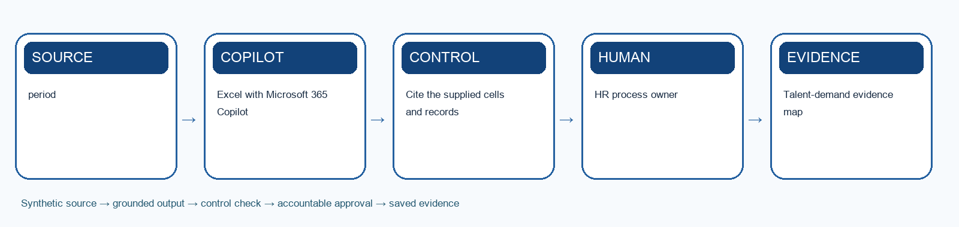
Workflow schematic: synthetic source → Copilot/agent → control → human approval → evidence.

Learning goal
Use Microsoft 365 Copilot to turn operational evidence into a transparent hire, redeploy or develop recommendation.

Tools
Excel with Microsoft 365 Copilot; Teams

Procedure
1. Review the synthetic demand, overtime, vacancy and skills-inventory evidence.
2. Define the business outcomes and time horizon for the new hub.
3. Ask Copilot to summarise demand drivers and cite the supporting cells.
4. Compare required capabilities with the current workforce skills inventory.
5. Create hire, redeploy, automate and develop options with assumptions and trade-offs.
6. Stress-test the preferred option against high- and low-demand scenarios.
7. Record the human-approved talent need, success measure and review date.
8. Pass the approved role outcomes and skills to Lab 2.

Test-it evidence
Record test ID, input, expected result, actual result, citation, reviewer and pass/fail. For agents, use the supplied test-case CSV and save the conversation or flow trace.

Product workbench
1. Sign in with the licensed training account. Use only the supplied synthetic `mock-data.csv` or evidence workbook; do not paste live HR records.
2. Open `Lab-01-Evidence-Workbook.xlsx`, inspect the Mock Data sheet and record the meaning of `period` and `forecast_orders` before prompting.
3. Save a working copy of the workbook in the approved OneDrive or SharePoint training location. In Excel, make the source range a named Table with headers, then open Copilot from the ribbon.
4. Ask Copilot to use the named table and cite `period` for each finding. Request an output table with evidence, uncertainty and an HR reviewer action.
5. Compare at least three claims with the original CSV rows. Write corrections and the exact prompt in the Evidence Log; do not treat a Copilot chart or summary as a final decision.
Microsoft product reference: https://support.microsoft.com/en-us/copilot-excel

Prompt scaffold
You are supporting the Microsoft Copilot for HR case. Use only the supplied synthetic evidence. Task: Use Microsoft 365 Copilot to turn operational evidence into a transparent hire, redeploy or develop recommendation. State assumptions, cite the evidence used, distinguish observation from inference, identify uncertainty, and list the human checks required before use.

Evidence to submit
- Talent-demand evidence map
- Skills-gap analysis
- Hire-redeploy-develop recommendation

Acceptance criteria
- Cite the supplied cells and records
- Separate fact from forecast
- Business and HR owners approve the demand hypothesis
The submission is complete when the workbook evidence log contains the input/source, prompt or design decision, output, verification, revision and named human owner.

Scenario questions
- Which assumption most changes the talent need?
- Where could automation reduce workload without removing accountability?
- What evidence would trigger a plan revision?

Lab 2: Draft an Inclusive Job Description with Generative AI

Scenario
Lab 1 established a need for a Workforce Operations Analyst. The old JD is task-heavy, contains copied requirements and does not reflect the outcomes or skills needed at the new hub.
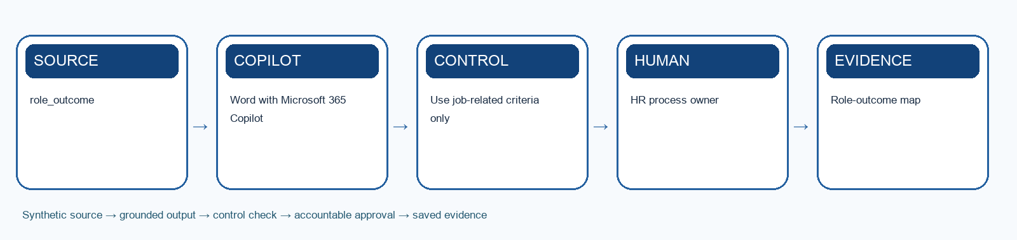
Workflow schematic: synthetic source → Copilot/agent → control → human approval → evidence.

Learning goal
Use Word Copilot to draft a skills-based, inclusive and approval-ready job description grounded in the approved talent need.

Tools
Word with Microsoft 365 Copilot; Excel

Procedure
1. Import the approved role outcomes and skills from Lab 1 or use the supplied fallback brief.
2. Identify obsolete, vague or non-job-related requirements in the legacy JD.
3. Prompt Copilot to draft purpose, outcomes, responsibilities and success measures.
4. Separate essential capabilities from skills that can be developed after hiring.
5. Add working conditions, reporting line and realistic candidate information.
6. Run inclusive-language, accessibility and fair-consideration checks.
7. Ask the hiring manager to validate each criterion and remove unsupported requirements.
8. Convert the final JD criteria into the anchored screening rubric for Lab 3.

Test-it evidence
Record test ID, input, expected result, actual result, citation, reviewer and pass/fail. For agents, use the supplied test-case CSV and save the conversation or flow trace.

Product workbench
1. Sign in with the licensed training account. Use only the supplied synthetic `mock-data.csv` or evidence workbook; do not paste live HR records.
2. Open `Lab-02-Evidence-Workbook.xlsx`, inspect the Mock Data sheet and record the meaning of `role_outcome` and `essential_skill` before prompting.
3. Open Word in the approved Microsoft 365 training account and create a new working document. Open Copilot from the ribbon and attach or reference the approved synthetic brief.
4. Paste the prompt scaffold below. Ask for a structured draft with criterion-to-source citations and a separate UNKNOWN list for unsupported requirements.
5. Track the edits you accept, compare each criterion or question with the source rubric, and ask the HR owner to approve the final version in the evidence workbook.
Microsoft product reference: https://support.microsoft.com/en-us/copilot-word

Prompt scaffold
You are supporting the Microsoft Copilot for HR case. Use only the supplied synthetic evidence. Task: Use Word Copilot to draft a skills-based, inclusive and approval-ready job description grounded in the approved talent need. State assumptions, cite the evidence used, distinguish observation from inference, identify uncertainty, and list the human checks required before use.

Evidence to submit
- Role-outcome map
- Inclusive job description
- Hiring-manager validation checklist

Acceptance criteria
- Use job-related criteria only
- Distinguish essential from trainable skills
- Hiring manager and HR approve every requirement
The submission is complete when the workbook evidence log contains the input/source, prompt or design decision, output, verification, revision and named human owner.

Scenario questions
- Which copied requirement would unnecessarily narrow the talent pool?
- What must the hiring manager verify rather than delegate to Copilot?
- How does the JD make later screening contestable?

Lab 3: Screen Resumes with a Fair Evidence Matrix

Scenario
Six synthetic candidates apply for the Workforce Operations Analyst role from Lab 2. Recruiters currently scan resumes inconsistently and retype evidence into spreadsheets.
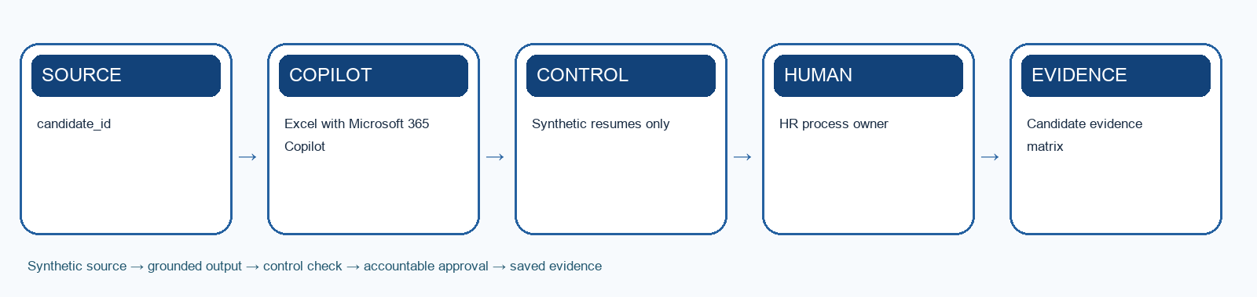
Workflow schematic: synthetic source → Copilot/agent → control → human approval → evidence.

Learning goal
Use Microsoft 365 Copilot to extract job-related evidence at speed while keeping shortlist decisions human, traceable and reviewable.

Tools
Excel with Microsoft 365 Copilot; Word

Procedure
1. Load the approved JD and anchored rubric from Lab 2 or use the supplied fallback rubric.
2. Review the six synthetic resumes without adding new criteria.
3. Prompt Copilot to extract evidence for each criterion and mark missing information as unknown.
4. Verify every extracted item against the source resume.
5. Calculate rubric results using transparent workbook formulas.
6. Check for proxy variables, inconsistent standards and false negative risk.
7. Record the authorised recruiter's shortlist decision separately from AI output.
8. Pass the shortlisted evidence and unresolved questions to Lab 4.

Test-it evidence
Record test ID, input, expected result, actual result, citation, reviewer and pass/fail. For agents, use the supplied test-case CSV and save the conversation or flow trace.

Product workbench
1. Sign in with the licensed training account. Use only the supplied synthetic `mock-data.csv` or evidence workbook; do not paste live HR records.
2. Open `Lab-03-Evidence-Workbook.xlsx`, inspect the Mock Data sheet and record the meaning of `candidate_id` and `skills_evidence` before prompting.
3. Save a working copy of the workbook in the approved OneDrive or SharePoint training location. In Excel, make the source range a named Table with headers, then open Copilot from the ribbon.
4. Ask Copilot to use the named table and cite `candidate_id` for each finding. Request an output table with evidence, uncertainty and an HR reviewer action.
5. Compare at least three claims with the original CSV rows. Write corrections and the exact prompt in the Evidence Log; do not treat a Copilot chart or summary as a final decision.
Microsoft product reference: https://support.microsoft.com/en-us/copilot-excel

Prompt scaffold
You are supporting the Microsoft Copilot for HR case. Use only the supplied synthetic evidence. Task: Use Microsoft 365 Copilot to extract job-related evidence at speed while keeping shortlist decisions human, traceable and reviewable. State assumptions, cite the evidence used, distinguish observation from inference, identify uncertainty, and list the human checks required before use.

Evidence to submit
- Candidate evidence matrix
- Uncertainty and bias log
- Human shortlist rationale

Acceptance criteria
- Synthetic resumes only
- Protected attributes and proxies excluded
- AI may organise evidence but cannot reject a candidate
The submission is complete when the workbook evidence log contains the input/source, prompt or design decision, output, verification, revision and named human owner.

Scenario questions
- Where could absence of evidence become an unfair negative assumption?
- How can a candidate challenge or correct the evidence?
- Which screening error creates the greatest harm?

Learning Unit 2: Microsoft 365 Copilot Across the HR Lifecycle
Generate and analyse with a human in control

Concept notes

A grounded prompt pattern
Context plus task plus constraints plus evidence produces reviewable work.
- Role and business context
- Specific task and desired outcome
- Approved sources and boundaries
- Output format and verification checks
Sources: https://www.microsoft.com/en-us/microsoft-copilot/copilot-101/ai-for-hr

Workforce planning
Copilot can turn fragmented evidence into an explainable workforce hypothesis.
- Summarise demand signals
- Identify capability gaps
- Draft role and capacity options
- Keep assumptions visible for challenge
Sources: https://www.gartner.com/en/human-resources/topics/artificial-intelligence-in-hr; https://www.microsoft.com/en-us/microsoft-copilot/copilot-101/ai-for-hr

Job design
Better job descriptions start with outcomes and skills, not copied history.
- Translate business need into outcomes
- Separate essential from trainable skills
- Use inclusive, job-related language
- Validate with hiring manager and policy
Sources: https://www.microsoft.com/en-us/microsoft-copilot/copilot-101/ai-for-hr; https://www.mom.gov.sg/employment-practices/fair-consideration-framework

Recruitment campaign
Copilot can adapt one approved proposition across channels without changing facts.
- Candidate persona and value proposition
- Channel-specific message
- Consistent salary and requirements
- Human approval before publication
Sources: https://www.microsoft.com/en-us/microsoft-copilot/copilot-101/ai-for-hr; https://www.sap.com/resources/ai-for-hr

Resume screening
AI should organise job-related evidence—not make an opaque hiring decision.
- Build a disclosed scoring rubric
- Extract evidence, uncertainty and gaps
- Blind protected attributes where feasible
- A human reviews every shortlist decision
Sources: https://www.microsoft.com/en-us/microsoft-copilot/copilot-101/ai-for-hr; https://www.mom.gov.sg/employment-practices/fair-consideration-framework

Structured interviewing
A shared evidence model improves consistency more than clever questions alone.
- Behavioural questions tied to outcomes
- Anchored scoring guide
- Independent notes before consensus
- Candidate accessibility and fairness checks
Sources: https://www.sap.com/resources/ai-for-hr; https://www.pdpc.gov.sg/help-and-resources/2020/01/model-ai-governance-framework

Candidate communication
Copilot can make communication timely, consistent and humane.
- Personalise only from approved facts
- Avoid inferred sensitive attributes
- Give realistic next steps
- Review tone, accuracy and confidentiality
Sources: https://www.microsoft.com/en-us/microsoft-copilot/copilot-101/ai-for-hr; https://www.pdpc.gov.sg/help-and-resources/2020/01/model-ai-governance-framework

Policy drafting
Copilot accelerates comparison and drafting; policy owners approve meaning.
- Ground in current policy sources
- Surface conflicts and missing definitions
- Use plain-language examples
- Preserve version, approver and effective date
Sources: https://www.microsoft.com/en-us/microsoft-copilot/copilot-101/ai-for-hr; https://www.zendesk.com/blog/ai/workflow-automation/ai-in-hr/

Onboarding
A personalised journey connects role, people, policy, systems and learning.
- Prepare a role-specific plan
- Summarise must-know policies
- Identify collaboration network
- Track access, milestones and feedback
Sources: https://adoption.microsoft.com/en-us/scenario-library/human-resources/improve-onboarding-and-development-processes-copilot-studio/; https://www.sap.com/resources/ai-for-hr

Personalisation across the employee journey
AI can tailor support when personalisation is grounded, explainable and correctable.
- Onboarding adapts approved tasks to role and location
- Learning recommendations connect evidenced gaps to approved resources
- Internal mobility surfaces explainable options rather than deterministic rankings
- Employee-service agents answer routine questions and escalate personal exceptions
Sources: AI Revolution in Human Resources: Transforming HR Management with Artificial Intelligence (2023 user-supplied ebook); https://www.microsoft.com/en-us/microsoft-copilot/copilot-101/ai-for-hr

Predictive talent analytics with guardrails
Forecasts should guide questions and planning, not make hidden decisions about people.
- Anticipate staffing needs from demand and skills evidence
- Identify organisational retention and capability patterns
- Test data quality, proxies, drift and uncertainty
- Keep high-potential, performance and wellbeing decisions human and contestable
Sources: AI Revolution in Human Resources: Transforming HR Management with Artificial Intelligence (2023 user-supplied ebook); https://www.pdpc.gov.sg/help-and-resources/2020/01/model-ai-governance-framework

Performance and development
Copilot can organise evidence and coaching preparation without replacing the conversation.
- Summarise agreed goals and evidence
- Separate observation from inference
- Draft balanced coaching questions
- Manager validates before discussion
Sources: https://www.microsoft.com/en-us/microsoft-copilot/copilot-101/ai-for-hr; https://www.sap.com/resources/ai-for-hr

Learning and internal mobility
Skills intelligence becomes useful when employees can challenge and update it.
- Map role outcomes to skills
- Recommend explainable learning options
- Support career conversations
- Avoid deterministic potential scores
Sources: https://www.gartner.com/en/human-resources/topics/artificial-intelligence-in-hr; https://www.sap.com/resources/ai-for-hr

Engagement and workforce insights
Patterns guide questions; they do not diagnose individuals.
- Aggregate data to protect privacy
- Triangulate survey, service and retention signals
- Show uncertainty and limitations
- Convert insight into a human-led action
Sources: https://www.gartner.com/en/human-resources/topics/artificial-intelligence-in-hr; https://www.pdpc.gov.sg/help-and-resources/2020/01/model-ai-governance-framework

Lab 4: Prepare and Review Structured Interviews with AI

Scenario
The recruiter shortlisted three candidates in Lab 3. Managers currently improvise interview questions, take incomplete notes and struggle to compare evidence consistently.
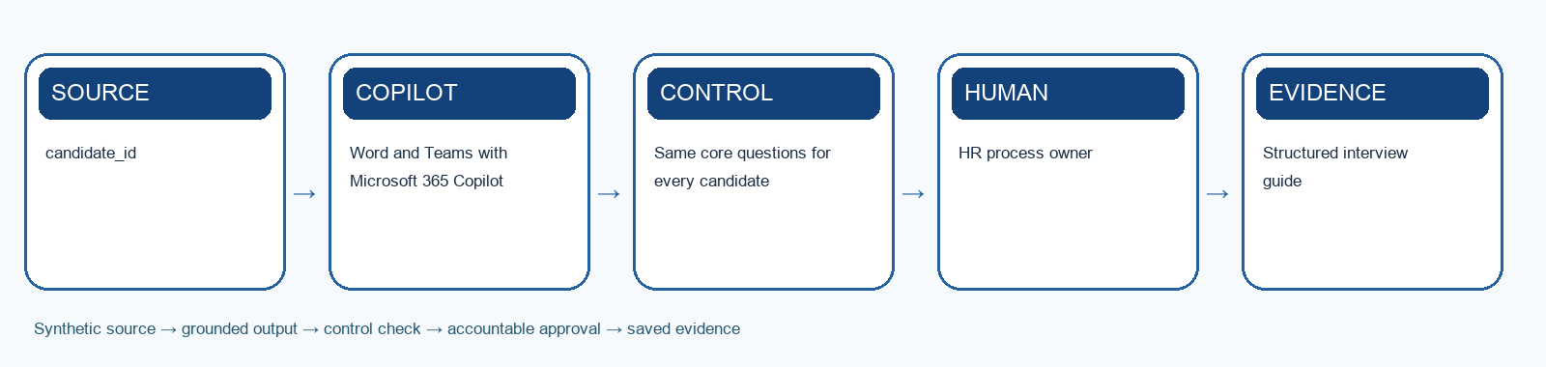
Workflow schematic: synthetic source → Copilot/agent → control → human approval → evidence.

Learning goal
Use Copilot to prepare job-related structured questions, organise synthetic interview notes and support a human panel decision.

Tools
Word and Teams with Microsoft 365 Copilot; Excel

Procedure
1. Review the JD outcomes, rubric and shortlisted evidence from Labs 2–3.
2. Ask Copilot to draft behavioural questions linked to each job outcome.
3. Create anchored indicators for strong, partial and insufficient evidence.
4. Add accessibility, candidate-consent and prohibited-question checks.
5. Run the supplied synthetic interview transcripts or role-play the panel.
6. Use Copilot to organise notes by criterion without inferring intent, truthfulness or personality.
7. Have panel members score independently, then record evidence-based consensus.
8. Draft consistent offer, hold and decline communications for human approval.

Test-it evidence
Record test ID, input, expected result, actual result, citation, reviewer and pass/fail. For agents, use the supplied test-case CSV and save the conversation or flow trace.

Product workbench
1. Sign in with the licensed training account. Use only the supplied synthetic `mock-data.csv` or evidence workbook; do not paste live HR records.
2. Open `Lab-04-Evidence-Workbook.xlsx`, inspect the Mock Data sheet and record the meaning of `candidate_id` and `question_id` before prompting.
3. Open Word in the approved Microsoft 365 training account and create a new working document. Open Copilot from the ribbon and attach or reference the approved synthetic brief.
4. Paste the prompt scaffold below. Ask for a structured draft with criterion-to-source citations and a separate UNKNOWN list for unsupported requirements.
5. Track the edits you accept, compare each criterion or question with the source rubric, and ask the HR owner to approve the final version in the evidence workbook.
Microsoft product reference: https://support.microsoft.com/en-us/copilot-word

Prompt scaffold
You are supporting the Microsoft Copilot for HR case. Use only the supplied synthetic evidence. Task: Use Copilot to prepare job-related structured questions, organise synthetic interview notes and support a human panel decision. State assumptions, cite the evidence used, distinguish observation from inference, identify uncertainty, and list the human checks required before use.

Evidence to submit
- Structured interview guide
- Anchored panel scorecard
- Candidate communication pack

Acceptance criteria
- Same core questions for every candidate
- No emotion or personality inference
- Panel members score independently before consensus
The submission is complete when the workbook evidence log contains the input/source, prompt or design decision, output, verification, revision and named human owner.

Scenario questions
- Which question best tests a role outcome rather than similarity to the panel?
- What interview evidence should Copilot never infer?
- How will disagreements between panel members be resolved?

Lab 5: Automate Onboarding Coordination

Scenario
A selected synthetic candidate joins HarbourLight as the Workforce Operations Analyst. Equipment, access, safety training and manager check-ins are currently coordinated through emails and spreadsheets, causing missed tasks and repeated follow-up.
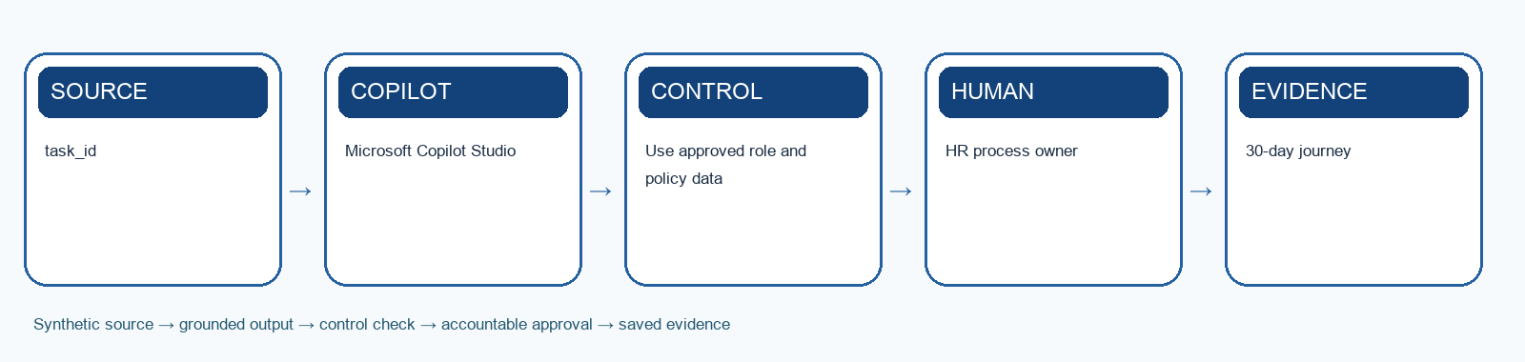
Workflow schematic: synthetic source → Copilot/agent → control → human approval → evidence.

Learning goal
Design a Copilot Studio onboarding agent that coordinates routine work while retaining accountable task owners and human confirmation.

Tools
Microsoft Copilot Studio; Teams; SharePoint; Power Automate or agent flows

Procedure
1. Map the Day 1, Week 1 and Days 8–30 employee outcomes.
2. Separate informational answers, recommendations and transactional tasks.
3. Use Copilot to draft a role-specific journey from approved JD and policy sources.
4. Create the agent purpose, instructions, knowledge and escalation boundaries.
5. Design deterministic tools for task creation, reminders and status retrieval.
6. Require human confirmation before closing access, equipment or safety tasks.
7. Test normal, missing-manager, late-equipment and confidential-question scenarios.
8. Record cycle-time reduction, exceptions and employee feedback for Lab 12.

Test-it evidence
Record test ID, input, expected result, actual result, citation, reviewer and pass/fail. For agents, use the supplied test-case CSV and save the conversation or flow trace.

Product workbench
1. Sign in with the licensed training account. Use only the supplied synthetic `mock-data.csv` or evidence workbook; do not paste live HR records.
2. Open `Lab-05-Evidence-Workbook.xlsx`, inspect the Mock Data sheet and record the meaning of `task_id` and `journey_stage` before prompting.
3. Open Copilot Studio in the approved training environment. Under Agents create a draft agent; set a clear name, purpose, instructions, authentication and escalation boundary.
4. Add only approved synthetic knowledge. If the scenario needs a transaction, create a deterministic flow from Workflows > New agent flow with typed inputs, validation, an approval gate and a status output.
5. For an agent-callable flow use a When an agent calls the flow trigger and Respond to the agent action. Add the published flow as a tool to the draft agent and map each input explicitly.
6. Use the agent Test pane with `agent-test-cases.csv`. Record the test ID, input, expected result, actual reply or tool trace, permission result, reviewer and pass/fail.
7. Do not publish the agent to a broad channel during class. A trainer may allow a private test after all normal, exception, duplicate and connector-failure cases pass.
Microsoft product reference: https://learn.microsoft.com/en-us/microsoft-copilot-studio/flows-overview

Prompt scaffold
You are supporting the Microsoft Copilot for HR case. Use only the supplied synthetic evidence. Task: Design a Copilot Studio onboarding agent that coordinates routine work while retaining accountable task owners and human confirmation. State assumptions, cite the evidence used, distinguish observation from inference, identify uncertainty, and list the human checks required before use.

Evidence to submit
- 30-day journey
- Agent conversation and tool map
- Onboarding test report

Acceptance criteria
- Use approved role and policy data
- Least-privilege connectors
- A human owner confirms every completion
The submission is complete when the workbook evidence log contains the input/source, prompt or design decision, output, verification, revision and named human owner.

Scenario questions
- Which work is safely automated and which remains owned by a person?
- Where could duplicate tasks be created?
- What proves the new joiner is ready rather than the checklist merely complete?

Lab 6: Create a Personalised Talent Development Journey

Scenario
After onboarding, the new analyst and two existing employees need different development pathways. HR currently assembles courses manually and managers lack a consistent skills-conversation structure.
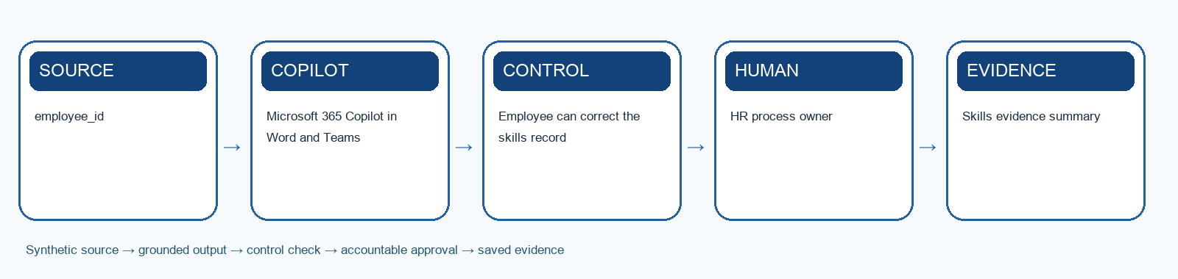
Workflow schematic: synthetic source → Copilot/agent → control → human approval → evidence.

Learning goal
Use Copilot and a bounded development agent to identify evidence-based skill gaps, prepare learning options and automate routine follow-up.

Tools
Microsoft 365 Copilot in Word and Teams; Agent Builder in Microsoft 365 Copilot; Excel

Procedure
1. Review the role outcomes, employee aspirations and synthetic performance evidence.
2. Separate observed capability, self-reported interest and unsupported inference.
3. Ask Copilot to map evidenced gaps to approved learning and stretch options.
4. Draft a 90-day plan with milestones, practice and manager support.
5. Create a bounded Agent Builder agent over approved learning resources.
6. Add instructions for explainable recommendations, consent and escalation.
7. Test irrelevant, inaccessible and sensitive development requests.
8. Record employee corrections, manager approval and follow-up reminders.

Test-it evidence
Record test ID, input, expected result, actual result, citation, reviewer and pass/fail. For agents, use the supplied test-case CSV and save the conversation or flow trace.

Product workbench
1. Sign in with the licensed training account. Use only the supplied synthetic `mock-data.csv` or evidence workbook; do not paste live HR records.
2. Open `Lab-06-Evidence-Workbook.xlsx`, inspect the Mock Data sheet and record the meaning of `employee_id` and `role_outcome` before prompting.
3. Open Microsoft 365 Copilot in a desktop browser. In the left pane choose New agent; use Describe or Configure to enter a purpose, audience and bounded instructions.
4. On Configure, add only approved training knowledge from SharePoint or OneDrive. Record the exact source title, owner, effective date and access boundary.
5. Create the agent, open it in Copilot and test one normal, one ambiguous, one outdated or unsupported, and one unauthorised request. Save the actual replies and citations.
6. If a reply lacks a citation or exceeds scope, revise the instructions or knowledge set and rerun the same test ID before sharing the agent.
Microsoft product reference: https://learn.microsoft.com/en-us/microsoft-365/copilot/extensibility/agent-templates-overview

Prompt scaffold
You are supporting the Microsoft Copilot for HR case. Use only the supplied synthetic evidence. Task: Use Copilot and a bounded development agent to identify evidence-based skill gaps, prepare learning options and automate routine follow-up. State assumptions, cite the evidence used, distinguish observation from inference, identify uncertainty, and list the human checks required before use.

Evidence to submit
- Skills evidence summary
- 90-day development plan
- Development-agent instructions and tests

Acceptance criteria
- Employee can correct the skills record
- No deterministic potential ranking
- Manager and employee choose the final plan
The submission is complete when the workbook evidence log contains the input/source, prompt or design decision, output, verification, revision and named human owner.

Scenario questions
- How can the employee challenge the skills profile?
- What would make a recommendation explainable?
- Which development decision should never be automated?

Learning Unit 3: Build Governed HR Agents
Agent Builder for knowledge; Copilot Studio for orchestration

Concept notes

Choose the build surface
Agent Builder is fast for team knowledge; Copilot Studio supports broader orchestration.
- Agent Builder: focused Q&A and team productivity
- Copilot Studio: tools, flows, channels and lifecycle
- Copy an agent to extend it
- Licensing and governance remain design constraints
Sources: https://www.microsoft.com/en-sg/microsoft-365-copilot/microsoft-copilot-studio; https://www.microsoft.com/en-us/microsoft-copilot/blog/copilot-studio/transform-hr-with-ai-powered-agents/

Agent Builder pattern
A useful team agent has a narrow purpose and authoritative knowledge.
- Name the audience and task
- Ground in selected SharePoint sources
- Add response and refusal instructions
- Share only with intended users
Sources: https://adoption.microsoft.com/en-us/scenario-library/human-resources/improve-onboarding-and-development-processes-copilot-studio/; https://www.microsoft.com/en-sg/microsoft-365-copilot/microsoft-copilot-studio

Copilot Studio pattern
An enterprise agent separates conversation, reasoning and transaction.
- Topic or generative orchestration
- Approved knowledge sources
- Actions and connectors
- Authentication, analytics and ALM
Sources: https://www.microsoft.com/en-sg/microsoft-365-copilot/microsoft-copilot-studio; https://www.awinfracloud.com/blog/build-hr-agent-copilot-studio

Integrate with the HR technology stack
Agents become useful when identity, HRIS data, workflows and monitoring are deliberately connected.
- HRIS and policy repositories remain authoritative systems of record
- Identity and permissions restrict personal data and transactions
- Connectors and APIs expose only bounded, validated actions
- Logging, fallback and human support make failures recoverable
Sources: AI Revolution in Human Resources: Transforming HR Management with Artificial Intelligence (2023 user-supplied ebook); https://www.microsoft.com/en-sg/microsoft-365-copilot/microsoft-copilot-studio

Knowledge grounding
The answer should be traceable to the current approved source.
- Curate source ownership
- Remove obsolete duplicates
- Respect permissions
- Return citation, effective date and escalation
Sources: https://www.awinfracloud.com/blog/build-hr-agent-copilot-studio; https://adoption.microsoft.com/en-us/ai-agents/employee-self-service-agent/

Instructions and boundaries
Agent instructions are an operating policy, not marketing copy.
- Define in-scope intents
- State prohibited decisions
- Specify clarification and escalation
- Require confirmation before consequential actions
Sources: https://www.ibm.com/think/topics/ai-agents-in-human-resources; https://www.pdpc.gov.sg/help-and-resources/2020/01/model-ai-governance-framework

Tools and agent flows
Tools convert a conversation into work; flows make critical actions deterministic.
- Use least-privilege connectors
- Validate inputs before action
- Add human approval for consequential steps
- Write outcome and error to an audit log
Sources: https://www.microsoft.com/en-us/microsoft-copilot/blog/copilot-studio/transform-hr-with-ai-powered-agents/; https://adoption.microsoft.com/en-us/ai-agents/employee-self-service-agent/

HR policy agent
A policy agent should answer, cite, qualify and escalate.
- Recognise the employee intent
- Retrieve the exact current clause
- Explain in plain language
- Escalate ambiguity or personal exceptions
Sources: https://www.awinfracloud.com/blog/build-hr-agent-copilot-studio; https://www.zendesk.com/blog/ai/workflow-automation/ai-in-hr/

Onboarding agent
An onboarding agent coordinates milestones without inventing employment commitments.
- Personalise from approved role data
- Trigger task owners and reminders
- Track exceptions and access blockers
- Route sensitive questions to HR
Sources: https://adoption.microsoft.com/en-us/scenario-library/human-resources/improve-onboarding-and-development-processes-copilot-studio/; https://www.microsoft.com/en-us/microsoft-copilot/blog/copilot-studio/transform-hr-with-ai-powered-agents/

Leave agent
The agent gathers intent; a governed workflow validates and records the request.
- Check balance and policy eligibility
- Confirm dates and coverage
- Route manager approval
- Update system and notify with audit evidence
Sources: https://adoption.microsoft.com/en-us/ai-agents/employee-self-service-agent/; https://www.microsoft.com/en-us/microsoft-copilot/blog/copilot-studio/transform-hr-with-ai-powered-agents/

Benefits, payroll and case triage
Self-service is valuable when the agent knows when not to answer.
- Handle common policy questions
- Retrieve authorised personal status
- Never expose another employee's data
- Escalate disputed or sensitive cases
Sources: https://www.zendesk.com/blog/ai/workflow-automation/ai-in-hr/; https://www.ibm.com/think/topics/ai-agents-in-human-resources

Offboarding agent
Offboarding requires coordination, access control and respectful communication.
- Confirm final date and obligations
- Trigger asset and access tasks
- Capture knowledge-transfer evidence
- Close only after owner confirmations
Sources: https://www.ibm.com/think/topics/ai-agents-in-human-resources; https://www.moveworks.com/us/en/resources/blog/agentic-ai-in-hr

Agent testing
Test conversations, actions, permissions and recovery—not only happy-path answers.
- Normal and ambiguous intents
- Prompt injection and data exfiltration
- Connector failures and duplicate actions
- Escalation, rollback and audit completeness
Sources: https://www.pdpc.gov.sg/help-and-resources/2020/01/model-ai-governance-framework; https://www.auxis.com/ai-in-hr-examples-types-use-cases-best-practices/

Lab 7: Draft and Operate an HR Policy Agent

Scenario
Hybrid-work and conduct guidance exists in conflicting files. HR repeatedly answers the same questions and managers sometimes apply outdated rules.
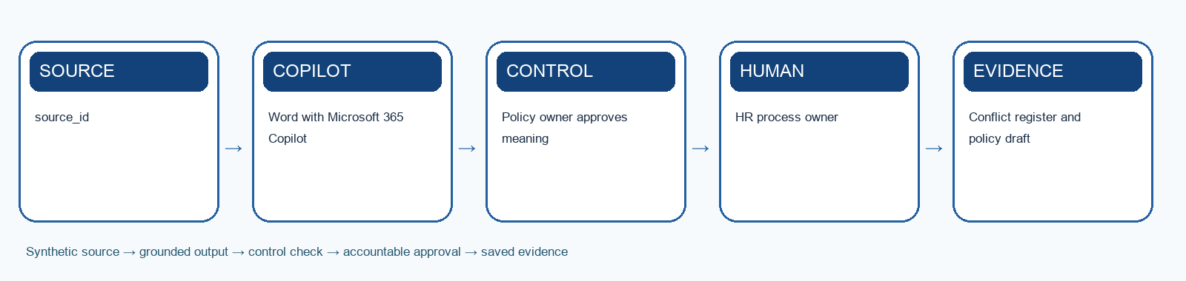
Workflow schematic: synthetic source → Copilot/agent → control → human approval → evidence.

Learning goal
Use Word Copilot to reconcile a controlled policy draft, then build an Agent Builder policy Q&A agent that cites the approved version.

Tools
Word with Microsoft 365 Copilot; Agent Builder in Microsoft 365 Copilot; SharePoint; Teams

Procedure
1. Compare the supplied policy extracts and identify conflicts, gaps and obsolete wording.
2. Confirm the authoritative rule hierarchy with the scenario brief.
3. Use Word Copilot to prepare a plain-language controlled draft.
4. Record approval, effective date, superseded versions and communication plan.
5. Create the Agent Builder purpose, knowledge and response boundaries.
6. Require citations, effective dates, clarification, refusal and escalation.
7. Test normal, ambiguous, outdated-policy and personal-exception questions.
8. Record administrative time saved and the new monitoring workload.

Test-it evidence
Record test ID, input, expected result, actual result, citation, reviewer and pass/fail. For agents, use the supplied test-case CSV and save the conversation or flow trace.

Product workbench
1. Sign in with the licensed training account. Use only the supplied synthetic `mock-data.csv` or evidence workbook; do not paste live HR records.
2. Open `Lab-07-Evidence-Workbook.xlsx`, inspect the Mock Data sheet and record the meaning of `source_id` and `policy_topic` before prompting.
3. Open Microsoft 365 Copilot in a desktop browser. In the left pane choose New agent; use Describe or Configure to enter a purpose, audience and bounded instructions.
4. On Configure, add only approved training knowledge from SharePoint or OneDrive. Record the exact source title, owner, effective date and access boundary.
5. Create the agent, open it in Copilot and test one normal, one ambiguous, one outdated or unsupported, and one unauthorised request. Save the actual replies and citations.
6. If a reply lacks a citation or exceeds scope, revise the instructions or knowledge set and rerun the same test ID before sharing the agent.
Microsoft product reference: https://learn.microsoft.com/en-us/microsoft-365/copilot/extensibility/agent-templates-overview

Prompt scaffold
You are supporting the Microsoft Copilot for HR case. Use only the supplied synthetic evidence. Task: Use Word Copilot to reconcile a controlled policy draft, then build an Agent Builder policy Q&A agent that cites the approved version. State assumptions, cite the evidence used, distinguish observation from inference, identify uncertainty, and list the human checks required before use.

Evidence to submit
- Conflict register and policy draft
- Agent instructions and knowledge map
- 8-case test report

Acceptance criteria
- Policy owner approves meaning
- Answers cite effective policy
- Ambiguous and sensitive cases escalate
The submission is complete when the workbook evidence log contains the input/source, prompt or design decision, output, verification, revision and named human owner.

Scenario questions
- What makes an answer grounded rather than plausible?
- Which exception requires a policy owner instead of an agent?
- What operating work is created when self-service is introduced?

Lab 8: Automate Leave Application and Approval

Scenario
Employees message leave dates to HR, which rekeys requests into a tracker and follows up with managers. Balance errors, overlaps and duplicate submissions create avoidable administration.
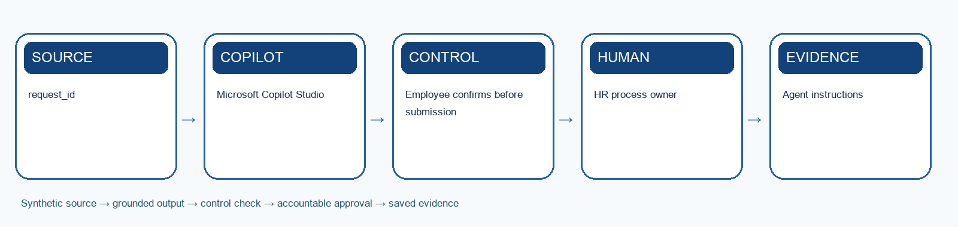
Workflow schematic: synthetic source → Copilot/agent → control → human approval → evidence.

Learning goal
Build a Copilot Studio leave agent plus deterministic approval flow for validation, confirmation, update and notification.

Tools
Microsoft Copilot Studio; Agent flows or Power Automate; Teams; Excel or HRIS sandbox

Procedure
1. Review the approved leave policy, balances, calendars and synthetic requests.
2. Define required inputs, privacy boundaries and validation messages.
3. Design the conversation to clarify dates, leave type, coverage and contact preferences.
4. Create deterministic checks for balance, overlap and approval routing.
5. Add a final employee confirmation before the agent invokes the flow.
6. Write approved, rejected and failed outcomes to the audit log.
7. Test insufficient balance, duplicate request, missing approver and connector failure.
8. Compare old rekeying time with the automated route and document human exceptions.

Test-it evidence
Record test ID, input, expected result, actual result, citation, reviewer and pass/fail. For agents, use the supplied test-case CSV and save the conversation or flow trace.

Product workbench
1. Sign in with the licensed training account. Use only the supplied synthetic `mock-data.csv` or evidence workbook; do not paste live HR records.
2. Open `Lab-08-Evidence-Workbook.xlsx`, inspect the Mock Data sheet and record the meaning of `request_id` and `employee_id` before prompting.
3. Open Copilot Studio in the approved training environment. Under Agents create a draft agent; set a clear name, purpose, instructions, authentication and escalation boundary.
4. Add only approved synthetic knowledge. If the scenario needs a transaction, create a deterministic flow from Workflows > New agent flow with typed inputs, validation, an approval gate and a status output.
5. For an agent-callable flow use a When an agent calls the flow trigger and Respond to the agent action. Add the published flow as a tool to the draft agent and map each input explicitly.
6. Use the agent Test pane with `agent-test-cases.csv`. Record the test ID, input, expected result, actual reply or tool trace, permission result, reviewer and pass/fail.
7. Do not publish the agent to a broad channel during class. A trainer may allow a private test after all normal, exception, duplicate and connector-failure cases pass.
Microsoft product reference: https://learn.microsoft.com/en-us/microsoft-copilot-studio/flows-overview

Prompt scaffold
You are supporting the Microsoft Copilot for HR case. Use only the supplied synthetic evidence. Task: Build a Copilot Studio leave agent plus deterministic approval flow for validation, confirmation, update and notification. State assumptions, cite the evidence used, distinguish observation from inference, identify uncertainty, and list the human checks required before use.

Evidence to submit
- Agent instructions
- Leave approval flow
- Audit log and exception test report

Acceptance criteria
- Employee confirms before submission
- Manager owns exceptions
- Idempotency prevents duplicate actions
The submission is complete when the workbook evidence log contains the input/source, prompt or design decision, output, verification, revision and named human owner.

Scenario questions
- Which rule belongs in the flow rather than the language model?
- How will the system detect a duplicate request?
- Who resolves a disputed leave balance?

Lab 9: Build a Benefits Self-Service Agent

Scenario
HR answers repetitive benefits questions by email and manually checks plan documents. Employees need fast information, but personal eligibility and claims require authenticated data and specialist review.
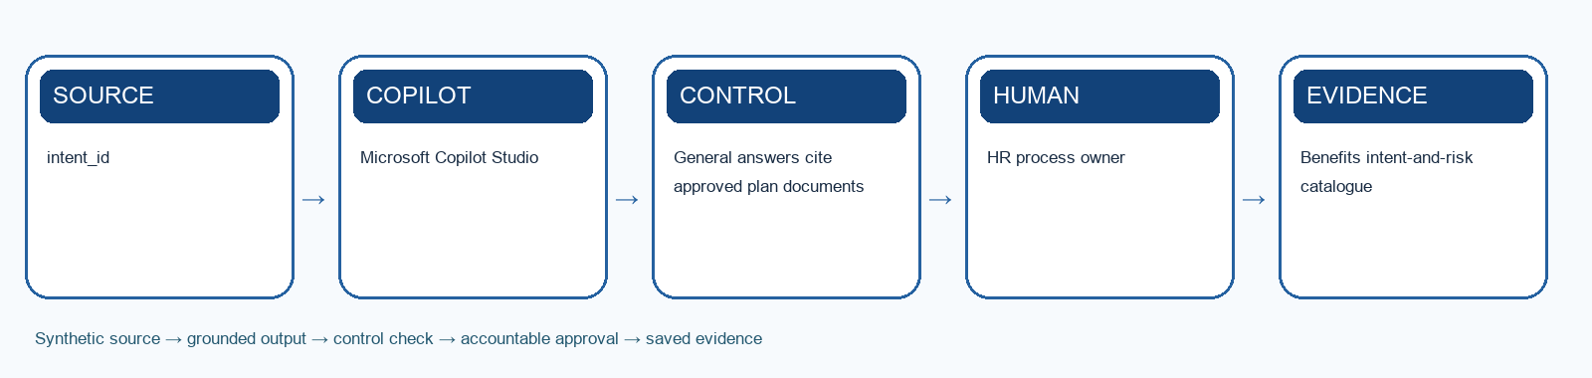
Workflow schematic: synthetic source → Copilot/agent → control → human approval → evidence.

Learning goal
Design a benefits agent that answers grounded general questions, retrieves authorised status and escalates consequential or sensitive cases.

Tools
Microsoft Copilot Studio; SharePoint; Teams; HRIS sandbox or mock connector

Procedure
1. Classify the supplied benefits intents as answer, retrieve, transact or escalate.
2. Map the minimum knowledge and personal data needed for each intent.
3. Create grounded responses for general coverage and enrolment questions.
4. Design an authenticated tool for personal status retrieval using least privilege.
5. Add refusal and escalation patterns for claims disputes, medical details and ambiguous eligibility.
6. Test cross-employee data leakage, prompt injection, outdated plans and connector failure.
7. Record resolution, citation, escalation and employee feedback.
8. Estimate first-contact resolution and HR administrative time returned.

Test-it evidence
Record test ID, input, expected result, actual result, citation, reviewer and pass/fail. For agents, use the supplied test-case CSV and save the conversation or flow trace.

Product workbench
1. Sign in with the licensed training account. Use only the supplied synthetic `mock-data.csv` or evidence workbook; do not paste live HR records.
2. Open `Lab-09-Evidence-Workbook.xlsx`, inspect the Mock Data sheet and record the meaning of `intent_id` and `employee_intent` before prompting.
3. Open Copilot Studio in the approved training environment. Under Agents create a draft agent; set a clear name, purpose, instructions, authentication and escalation boundary.
4. Add only approved synthetic knowledge. If the scenario needs a transaction, create a deterministic flow from Workflows > New agent flow with typed inputs, validation, an approval gate and a status output.
5. For an agent-callable flow use a When an agent calls the flow trigger and Respond to the agent action. Add the published flow as a tool to the draft agent and map each input explicitly.
6. Use the agent Test pane with `agent-test-cases.csv`. Record the test ID, input, expected result, actual reply or tool trace, permission result, reviewer and pass/fail.
7. Do not publish the agent to a broad channel during class. A trainer may allow a private test after all normal, exception, duplicate and connector-failure cases pass.
Microsoft product reference: https://learn.microsoft.com/en-us/microsoft-copilot-studio/flows-overview

Prompt scaffold
You are supporting the Microsoft Copilot for HR case. Use only the supplied synthetic evidence. Task: Design a benefits agent that answers grounded general questions, retrieves authorised status and escalates consequential or sensitive cases. State assumptions, cite the evidence used, distinguish observation from inference, identify uncertainty, and list the human checks required before use.

Evidence to submit
- Benefits intent-and-risk catalogue
- Knowledge and tool design
- Privacy and regression test report

Acceptance criteria
- General answers cite approved plan documents
- Personal requests require authentication
- No medical, legal or final entitlement advice
The submission is complete when the workbook evidence log contains the input/source, prompt or design decision, output, verification, revision and named human owner.

Scenario questions
- Why should one conversational front door not have one permission set?
- Which benefits question requires immediate human review?
- How will employees know the source and effective date of an answer?

Learning Unit 4: Responsible Adoption and HR Transformation
Govern decisions, data, people and agent operations

Concept notes

Why HR AI is high consequence
Employment decisions affect opportunity, income, dignity and trust.
- Recruitment and promotion shape opportunity
- Performance evidence can be incomplete
- Employee data is sensitive
- Power asymmetry raises consent concerns
Sources: https://www.pdpc.gov.sg/help-and-resources/2020/01/model-ai-governance-framework; https://www.mom.gov.sg/employment-practices/fair-consideration-framework

Human involvement by impact
More consequential and less reversible decisions need stronger human authority.
- Inform: AI drafts or retrieves
- Recommend: AI proposes with evidence
- Approve: authorised human decides
- Execute: agent acts only within approved bounds
Sources: https://www.pdpc.gov.sg/help-and-resources/2020/01/model-ai-governance-framework; https://www.strategyand.pwc.com/de/en/functions/organisational-strategy/agentic-ai-in-hr.html

From HR efficiency to enterprise value
The strongest human-AI partnerships deliver better workforce solutions, speed and business impact.
- Workforce solutions become more personalised and responsive
- Agile portfolio management reduces time from need to usable service
- Administrative capacity shifts to strategic and business-facing work
- AI and technology fluency becomes a capability across HR, not an HRIS silo
Sources: Deloitte, The Future of HR, Powered by AI (user-supplied reference deck)

Four implementation case vignettes
The supplied ebook illustrates value across recruitment, engagement, talent and performance.
- Technology: screening and candidate chat; reported 30% faster hiring
- Retail: feedback analysis; reported 20% lower turnover
- Financial services: predictive talent and succession development
- Healthcare: timely evidence for coaching and reviews
Sources: AI Revolution in Human Resources: Transforming HR Management with Artificial Intelligence (2023 user-supplied ebook)

What successful implementations share
Technology works when objectives, people, monitoring and cross-functional ownership reinforce one another.
- Start with a clear employee or business outcome
- Involve employees early in design, testing and feedback
- Continuously monitor quality, bias, drift and unintended effects
- Pair HR process ownership with IT, legal, security and data expertise
Sources: AI Revolution in Human Resources: Transforming HR Management with Artificial Intelligence (2023 user-supplied ebook)

Privacy by design
Minimise data before asking a model to protect it.
- Purpose and lawful use
- Minimum necessary fields
- Access, retention and deletion
- Incident and data-subject response
Sources: https://www.pdpc.gov.sg/help-and-resources/2020/01/model-ai-governance-framework

Fair hiring controls
Selection criteria must remain job-related, reviewable and consistently applied.
- Fairly consider candidates
- Exclude non-job-related protected traits
- Keep interview and decision evidence
- Provide human challenge and correction
Sources: https://www.mom.gov.sg/employment-practices/fair-consideration-framework; https://www.pdpc.gov.sg/help-and-resources/2020/01/model-ai-governance-framework

Bias is a system property
Bias can enter through objectives, data, prompts, tools and human use.
- Question proxy variables
- Compare outcomes across relevant groups
- Review false positives and negatives
- Change process, not only the prompt
Sources: https://www.pdpc.gov.sg/help-and-resources/2020/01/model-ai-governance-framework; https://www.sap.com/resources/ai-for-hr

Transparency and explainability
Employees need to know when AI is used and how to seek help.
- Disclose the AI role
- Show source and material factors
- Explain limits and uncertainty
- Provide an accessible human channel
Sources: https://www.pdpc.gov.sg/help-and-resources/2020/01/model-ai-governance-framework

Security and prompt injection
An agent can be manipulated through the text it reads.
- Treat retrieved content as untrusted
- Separate instructions from data
- Allow-list tools and destinations
- Monitor anomalous actions
Sources: https://www.pdpc.gov.sg/help-and-resources/2020/01/model-ai-governance-framework; https://www.microsoft.com/en-sg/microsoft-365-copilot/microsoft-copilot-studio

Agent identity and least privilege
Every action should be attributable to an authorised identity.
- Use named service or user context
- Grant only required permissions
- Separate maker, approver and operator roles
- Review access and dormant agents
Sources: https://www.microsoft.com/en-sg/microsoft-365-copilot/microsoft-copilot-studio; https://www.ibm.com/think/topics/ai-agents-in-human-resources

Operational controls
Agents are digital workers that need owners, logs, limits and retirement.
- Named business and technical owners
- Versioned instructions and knowledge
- Run-time monitoring and kill switch
- Periodic validation and decommissioning
Sources: https://www.hrci.org/community/blogs-and-announcements/hr-leads-business-blog/hr-leads-business/2025/08/21/agentic-ai-in-hr; https://www.strategyand.pwc.com/de/en/functions/organisational-strategy/agentic-ai-in-hr.html

Success measures
Measure service, adoption, quality, risk and human value together.
- Cycle time and first-contact resolution
- Accuracy and evidence completeness
- Escalation and override rates
- Employee trust and time returned to people
Sources: https://www.mckinsey.com/capabilities/people-and-organizational-performance/our-insights/the-organization-blog/four-ways-to-start-using-generative-ai-in-hr; https://www.gartner.com/en/human-resources/topics/artificial-intelligence-in-hr

Change and AI literacy
Adoption depends on role clarity and practical learning.
- Explain what changes and what does not
- Train prompting, review and escalation
- Create champions and feedback loops
- Recognise new work: agent owner, tester, steward
Sources: https://www.gartner.com/en/human-resources/topics/artificial-intelligence-in-hr; https://www.auxis.com/ai-in-hr-examples-types-use-cases-best-practices/

Build HR's AI capability
HR needs literacy, ethical judgement, product thinking and change leadership to operate AI well.
- Teach AI capabilities, limitations and evidence review
- Establish privacy, fairness and responsible-use guidelines
- Create cross-functional teams for design and sustainment
- Communicate role changes and build continuous learning into work
Sources: AI Revolution in Human Resources: Transforming HR Management with Artificial Intelligence (2023 user-supplied ebook); Deloitte, The Future of HR, Powered by AI (user-supplied reference deck)

90-day responsible roadmap
Move from a bounded pilot to an owned capability through evidence gates.
- Days 1–30: baseline, risk and prototype
- Days 31–60: test, controls and user feedback
- Days 61–90: measured pilot and operating handover
- Scale only when value and control thresholds pass
Sources: https://www.strategyand.pwc.com/de/en/functions/organisational-strategy/agentic-ai-in-hr.html; https://www.auxis.com/ai-in-hr-examples-types-use-cases-best-practices/

Lab 10: Use AI for Workforce Wellness Insights

Scenario
HarbourLight has pulse surveys, absence patterns and workload data, but HR spends days combining them. Leaders want early signals without monitoring or diagnosing individuals.
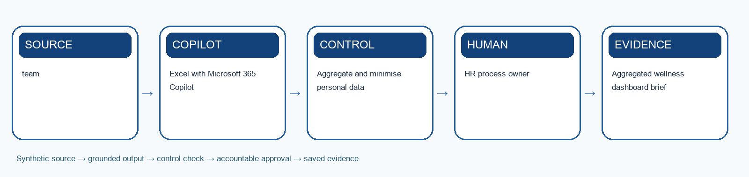
Workflow schematic: synthetic source → Copilot/agent → control → human approval → evidence.

Learning goal
Use Copilot to analyse aggregated wellness evidence, identify organisational questions and prepare human-led interventions.

Tools
Excel with Microsoft 365 Copilot; Teams; Word

Procedure
1. Review the synthetic aggregated survey, workload and absence tables.
2. Check denominators, missing groups, small samples and data quality.
3. Ask Copilot to identify patterns with cell references and uncertainty.
4. Separate correlation, employee voice and unsupported causal claims.
5. Create organisational hypotheses about workload, support and work design.
6. Draft options such as manager support, process redesign and voluntary resources.
7. Run privacy, stigma, fairness and communication checks.
8. Record the human owner, feedback route and measures for evaluating the intervention.

Test-it evidence
Record test ID, input, expected result, actual result, citation, reviewer and pass/fail. For agents, use the supplied test-case CSV and save the conversation or flow trace.

Product workbench
1. Sign in with the licensed training account. Use only the supplied synthetic `mock-data.csv` or evidence workbook; do not paste live HR records.
2. Open `Lab-10-Evidence-Workbook.xlsx`, inspect the Mock Data sheet and record the meaning of `team` and `survey_n` before prompting.
3. Save a working copy of the workbook in the approved OneDrive or SharePoint training location. In Excel, make the source range a named Table with headers, then open Copilot from the ribbon.
4. Ask Copilot to use the named table and cite `team` for each finding. Request an output table with evidence, uncertainty and an HR reviewer action.
5. Compare at least three claims with the original CSV rows. Write corrections and the exact prompt in the Evidence Log; do not treat a Copilot chart or summary as a final decision.
Microsoft product reference: https://support.microsoft.com/en-us/copilot-excel

Prompt scaffold
You are supporting the Microsoft Copilot for HR case. Use only the supplied synthetic evidence. Task: Use Copilot to analyse aggregated wellness evidence, identify organisational questions and prepare human-led interventions. State assumptions, cite the evidence used, distinguish observation from inference, identify uncertainty, and list the human checks required before use.

Evidence to submit
- Aggregated wellness dashboard brief
- Evidence-and-limitation log
- Human-led intervention proposal

Acceptance criteria
- Aggregate and minimise personal data
- No diagnosis or individual risk scoring
- Employees have a clear human support route
The submission is complete when the workbook evidence log contains the input/source, prompt or design decision, output, verification, revision and named human owner.

Scenario questions
- Which attractive insight is not safe to act on?
- How does aggregation reduce but not eliminate privacy risk?
- What response supports people without surveillance?

Lab 11: Automate Safe Employee Offboarding

Scenario
A synthetic employee is leaving HarbourLight. HR currently coordinates payroll, assets, access, knowledge transfer and exit communication through separate emails, creating missed tasks and security risk.
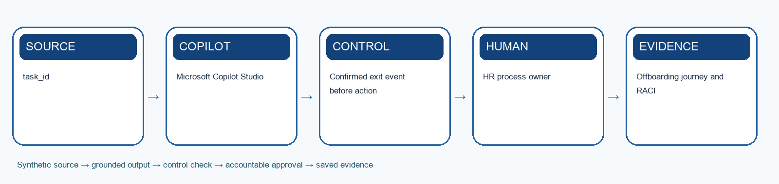
Workflow schematic: synthetic source → Copilot/agent → control → human approval → evidence.

Learning goal
Design a Copilot Studio offboarding agent and controlled flow that reduces follow-up while preserving separation of duties and respectful communication.

Tools
Microsoft Copilot Studio; Power Automate or agent flows; Teams; SharePoint; HRIS sandbox

Procedure
1. Confirm the synthetic exit type, date, obligations and accountable owners.
2. Map employee, manager, HR, payroll, IT, facilities and knowledge-transfer outcomes.
3. Use Copilot to draft respectful, role-appropriate communications.
4. Create agent instructions that disclose status without exposing sensitive reasons.
5. Design deterministic tasks for assets, final pay, access and records.
6. Require authorised confirmation before disabling access or closing obligations.
7. Test cancelled exit, early access removal, missing asset, data leakage and connector failure.
8. Record completion evidence, employee experience and lessons for Lab 12.

Test-it evidence
Record test ID, input, expected result, actual result, citation, reviewer and pass/fail. For agents, use the supplied test-case CSV and save the conversation or flow trace.

Product workbench
1. Sign in with the licensed training account. Use only the supplied synthetic `mock-data.csv` or evidence workbook; do not paste live HR records.
2. Open `Lab-11-Evidence-Workbook.xlsx`, inspect the Mock Data sheet and record the meaning of `task_id` and `offboarding_outcome` before prompting.
3. Open Copilot Studio in the approved training environment. Under Agents create a draft agent; set a clear name, purpose, instructions, authentication and escalation boundary.
4. Add only approved synthetic knowledge. If the scenario needs a transaction, create a deterministic flow from Workflows > New agent flow with typed inputs, validation, an approval gate and a status output.
5. For an agent-callable flow use a When an agent calls the flow trigger and Respond to the agent action. Add the published flow as a tool to the draft agent and map each input explicitly.
6. Use the agent Test pane with `agent-test-cases.csv`. Record the test ID, input, expected result, actual reply or tool trace, permission result, reviewer and pass/fail.
7. Do not publish the agent to a broad channel during class. A trainer may allow a private test after all normal, exception, duplicate and connector-failure cases pass.
Microsoft product reference: https://learn.microsoft.com/en-us/microsoft-copilot-studio/flows-overview

Prompt scaffold
You are supporting the Microsoft Copilot for HR case. Use only the supplied synthetic evidence. Task: Design a Copilot Studio offboarding agent and controlled flow that reduces follow-up while preserving separation of duties and respectful communication. State assumptions, cite the evidence used, distinguish observation from inference, identify uncertainty, and list the human checks required before use.

Evidence to submit
- Offboarding journey and RACI
- Tool and approval map
- Security, privacy and failure test report

Acceptance criteria
- Confirmed exit event before action
- Separate HR, payroll, asset and access approvals
- Knowledge and personal data retention are purpose-limited
The submission is complete when the workbook evidence log contains the input/source, prompt or design decision, output, verification, revision and named human owner.

Scenario questions
- What evidence is required before access is removed?
- Where is separation of duties essential?
- How can automation preserve dignity during exit?

Lab 12: Capstone: Operate the HR Agent Control Room

Scenario
HarbourLight now uses generative AI and agents across talent planning, hiring, onboarding, development, policy, leave, benefits, wellness and offboarding. Leaders must decide what to scale, remediate, pause or retire.
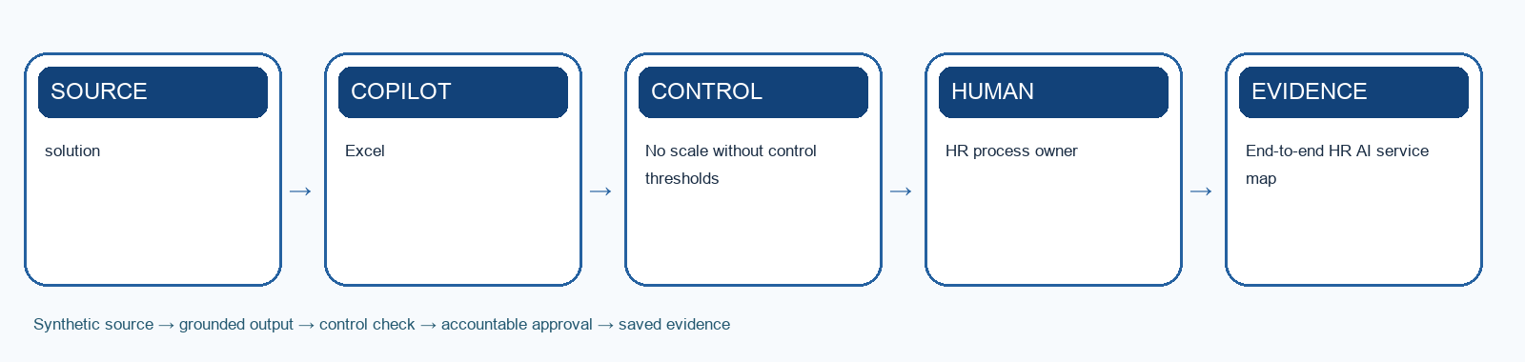
Workflow schematic: synthetic source → Copilot/agent → control → human approval → evidence.

Learning goal
Use lifecycle, service, risk, adoption and human-value evidence to govern the full HR AI operating system.

Tools
Excel; Teams; Microsoft 365 Copilot

Procedure
1. Map every activity from talent need to offboarding and identify hand-offs between Copilot, agents, flows and humans.
2. Review the synthetic cycle-time, quality, adoption, escalation, incident and feedback evidence.
3. Validate denominator, baseline, target and trend for each metric.
4. Ask Copilot to summarise evidence with cell references and explicit limitations.
5. Identify control failures, unintended outcomes, administrative work returned and new operating work created.
6. Classify each solution as scale, remediate, pause or retire and respond to the supplied incident.
7. Create a 90-day roadmap with decision gates, accountable owners and retirement paths.
8. Present a three-minute executive recommendation and answer peer challenge questions.

Test-it evidence
Record test ID, input, expected result, actual result, citation, reviewer and pass/fail. For agents, use the supplied test-case CSV and save the conversation or flow trace.

Product workbench
1. Sign in with the licensed training account. Use only the supplied synthetic `mock-data.csv` or evidence workbook; do not paste live HR records.
2. Open `Lab-12-Evidence-Workbook.xlsx`, inspect the Mock Data sheet and record the meaning of `solution` and `baseline_minutes` before prompting.
3. Save a working copy of the workbook in the approved OneDrive or SharePoint training location. In Excel, make the source range a named Table with headers, then open Copilot from the ribbon.
4. Ask Copilot to use the named table and cite `solution` for each finding. Request an output table with evidence, uncertainty and an HR reviewer action.
5. Compare at least three claims with the original CSV rows. Write corrections and the exact prompt in the Evidence Log; do not treat a Copilot chart or summary as a final decision.
Microsoft product reference: https://support.microsoft.com/en-us/copilot-excel

Prompt scaffold
You are supporting the Microsoft Copilot for HR case. Use only the supplied synthetic evidence. Task: Use lifecycle, service, risk, adoption and human-value evidence to govern the full HR AI operating system. State assumptions, cite the evidence used, distinguish observation from inference, identify uncertainty, and list the human checks required before use.

Evidence to submit
- End-to-end HR AI service map
- Agent scorecard and incident response
- 90-day roadmap and executive recommendation

Acceptance criteria
- No scale without control thresholds
- Employee feedback included
- Named owner and retirement path
The submission is complete when the workbook evidence log contains the input/source, prompt or design decision, output, verification, revision and named human owner.

Scenario questions
- Which metric looked good but hid harm?
- What evidence justifies scale?
- How will the organisation retire an agent safely?

Responsible HR AI checklist
☐ Purpose and scope are explicit.
☐ Only necessary and authorised data are used.
☐ Job-related evidence and fair criteria are documented.
☐ Sources, uncertainty and limitations are visible.
☐ Consequential decisions have an authorised human approver.
☐ Agent identity, permissions, tools and destinations use least privilege.
☐ Normal, edge, adversarial and failure cases are tested.
☐ Logs, incidents, feedback, change and retirement have owners.

Source register
The complete reviewed source register, access status and cross-artifact coverage matrix are maintained in SOURCE-COVERAGE.md alongside the courseware. Key authoritative anchors include Microsoft product/adoption guidance, Singapore PDPC's Model AI Governance Framework and Singapore MOM's Fair Consideration Framework.

